Your name:

Class being observed:

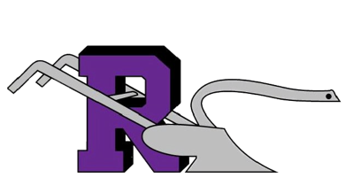
Date:

Secondary Observation Sheet

Focal Strategy:

Was the focus strategy observed? Yes/ No

I saw:

I heard:

I Wonder:

Check the strategies that were observed.

- Writing (to learn or learning to write)
- Collaboration
- Organization (physical or cognitive)
- Inquiry (two-way questioning)
- Reading (to learn or learning to read)
- Classroom Talk
- Scaffolding

Were objectives posted? Yes/ No

